Estado actual del servidor SMTP

/etc/modprobe.d/CIS.conf

install cramfs /bin/true
install freevxfs /bin/true
install jffs2 /bin/true
install hfs /bin/true
install hfsplus /bin/true
install squashfs /bin/true
install udf /bin/true
install vfat /bin/true

fdisk -l
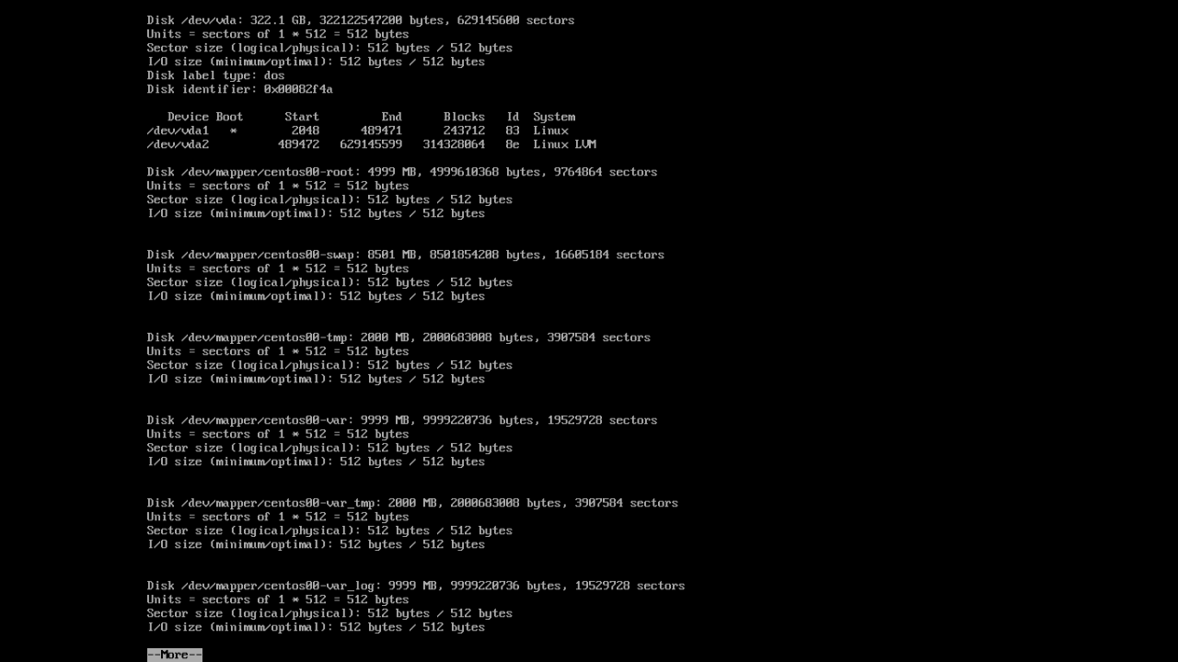
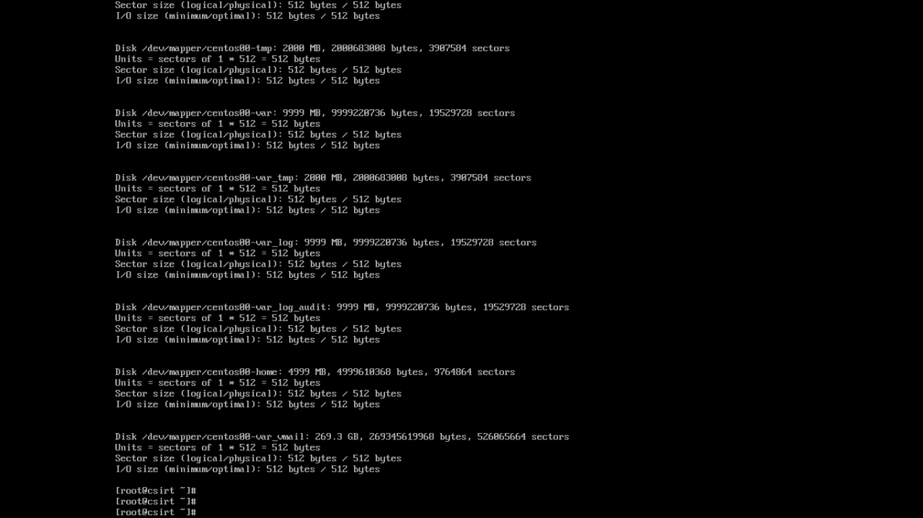

mount
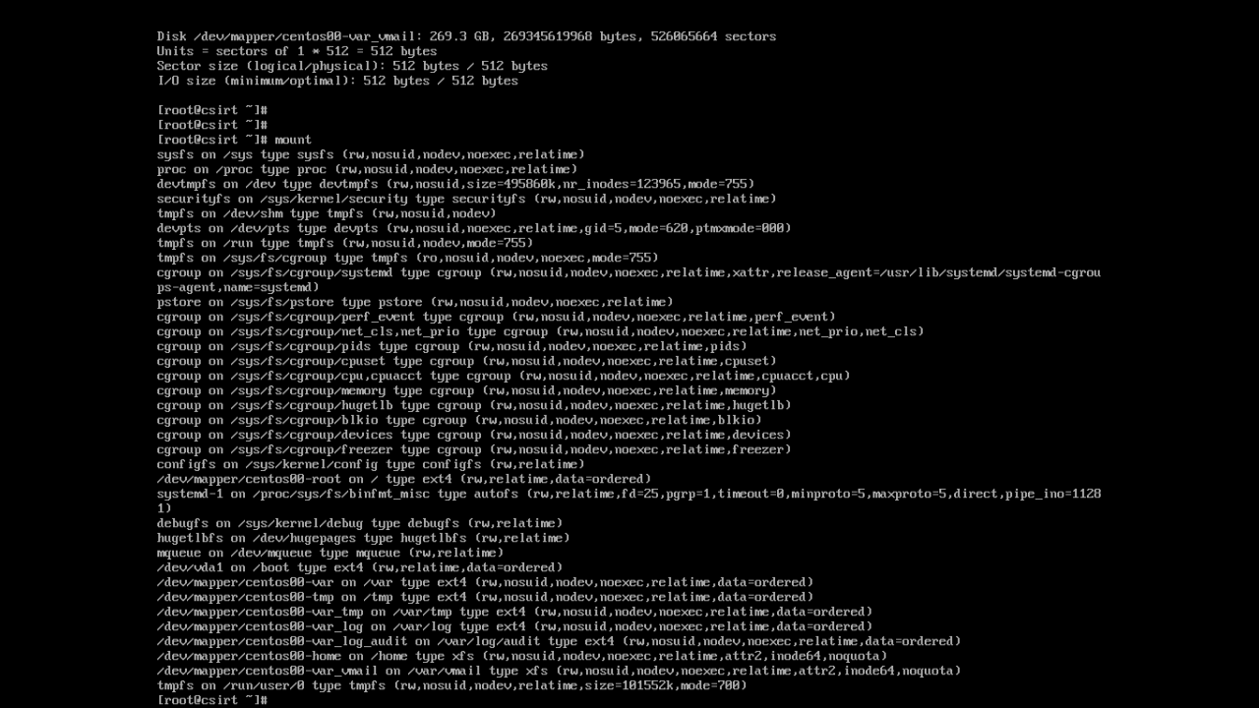
/var/lib/aide/aidecheck.sh
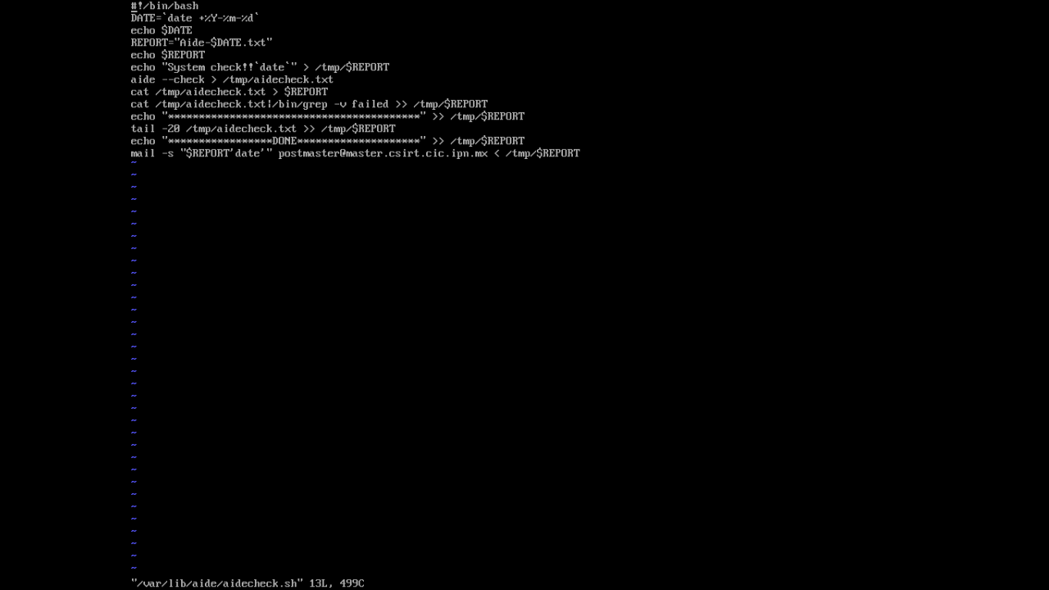

crontab -u root -e
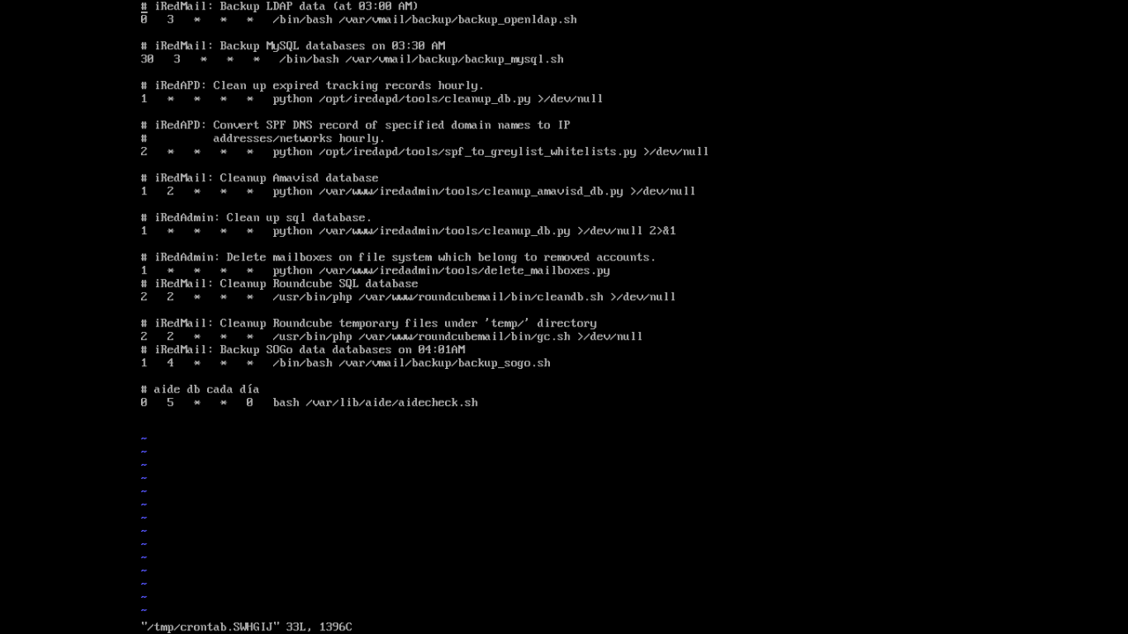
/etc/security/limits.d/20-nproc.conf


/etc/sysctl.d/99-sysctl.conf
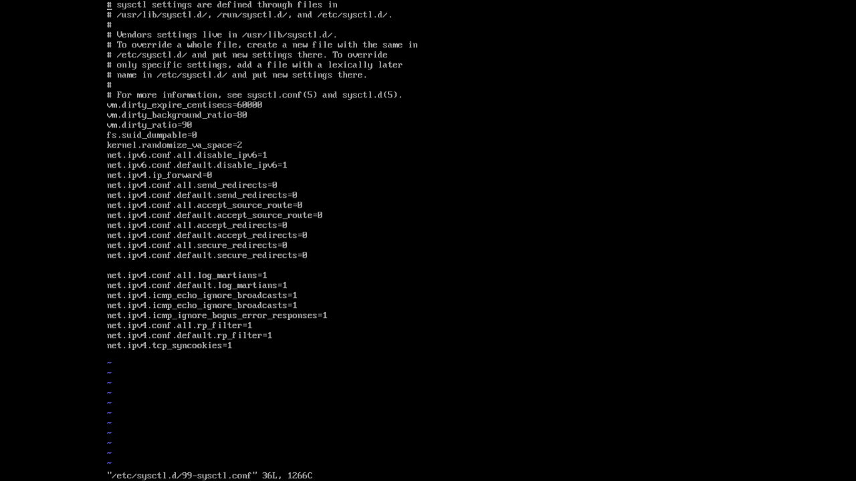
/etc/logrotate.conf
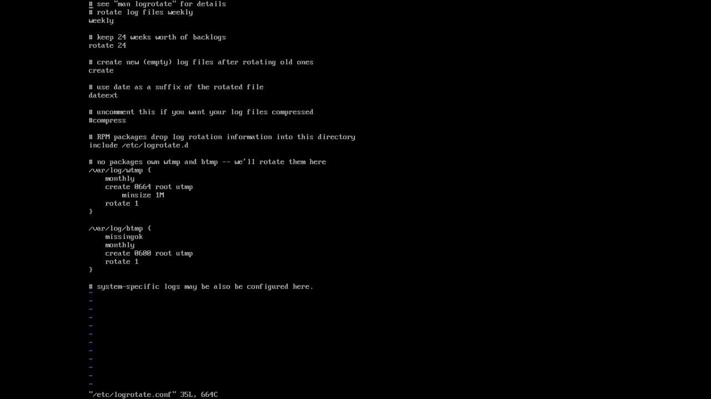

/root/filesCheck.sh
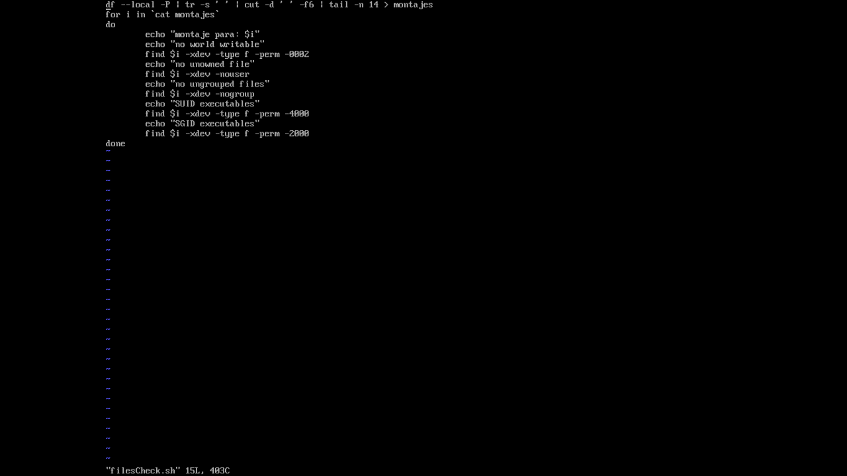
/etc/hosts.deny
ALL: ALL

/etc/hosts.allow
ALL: 148.204.

/root/firewall.sh
#!/bin/bash
# Flush IPtables rules
iptables -F
iptables -X

# Ensure default deny firewall policy
iptables -P INPUT DROP
iptables -P OUTPUT DROP
iptables -P FORWARD DROP

# Ensure loopback traffic is configured
iptables -A INPUT -i lo -j ACCEPT
iptables -A OUTPUT -o lo -j ACCEPT
iptables -A INPUT -s 127.0.0.0/8 -j DROP

# Ensure connections to mail server are open
iptables -A INPUT -p tcp –dport 80 -m conntrack –cstate -s 148.204..66.93 NEW,ESTABLISHED -j ACCEPT
iptables -A OUTPUT -p tcp –dport 80 -m conntrack –cstate -s 148.204..66.93 NEW,ESTABLISHED -j ACCEPT

iptables -A INPUT -p tcp –dport 443 -m conntrack –cstate -s 148.204..66.93 NEW,ESTABLISHED -j ACCEPT
iptables -A OUTPUT -p tcp –dport 443 -m conntrack –cstate -s 148.204..66.93 NEW,ESTABLISHED -j ACCEPT

iptables -A INPUT -p tcp –dport 25 -m conntrack –cstate NEW,ESTABLISHED -j ACCEPT
iptables -A OUTPUT -p tcp –dport 25 -m conntrack –cstate NEW,ESTABLISHED -j ACCEPT

iptables -A INPUT -p tcp –dport 587 -m conntrack –cstate NEW,ESTABLISHED -j ACCEPT
iptables -A OUTPUT -p tcp –dport 587 -m conntrack –cstate NEW,ESTABLISHED -j ACCEPT

iptables -A INPUT -p tcp –dport 143 -m conntrack –cstate -s 148.204..66.93 NEW,ESTABLISHED -j ACCEPT
iptables -A OUTPUT -p tcp –dport 143 -m conntrack –cstate -s 148.204..66.93 NEW,ESTABLISHED -j ACCEPT

iptables -A INPUT -p tcp –dport 993 -m conntrack –cstate -s 148.204..66.93 NEW,ESTABLISHED -j ACCEPT
iptables -A OUTPUT -p tcp –dport 993 -m conntrack –cstate -s 148.204..66.93 NEW,ESTABLISHED -j ACCEPT

ip de nuestro segmento: 148.204.66.93

A la configuración de rsyslog se le agregó la línea: $FileCreateMode 0640

Preguntar si hay un servidor NTP o chrony en el CIC para sincronizar todos los equipos

/root/resultadoPaso6.txt
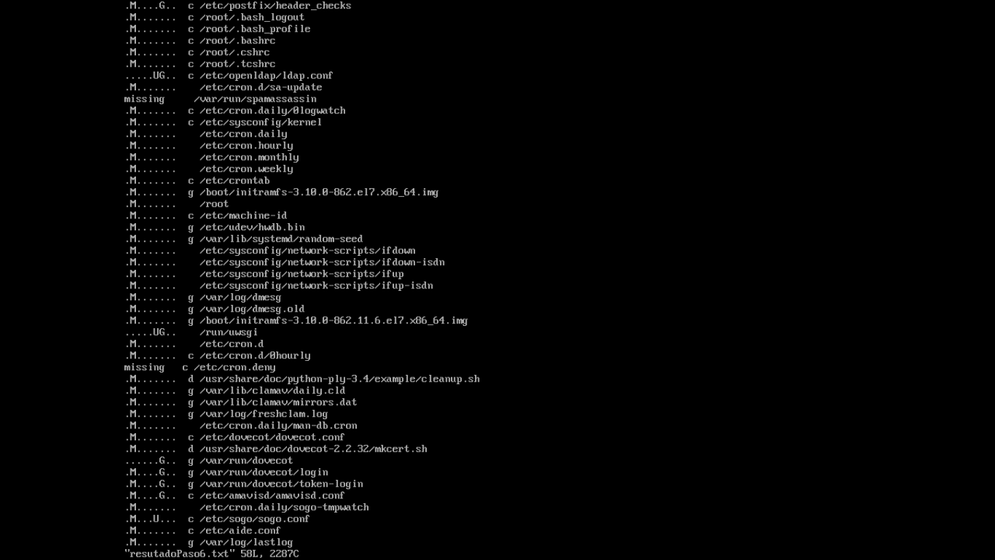
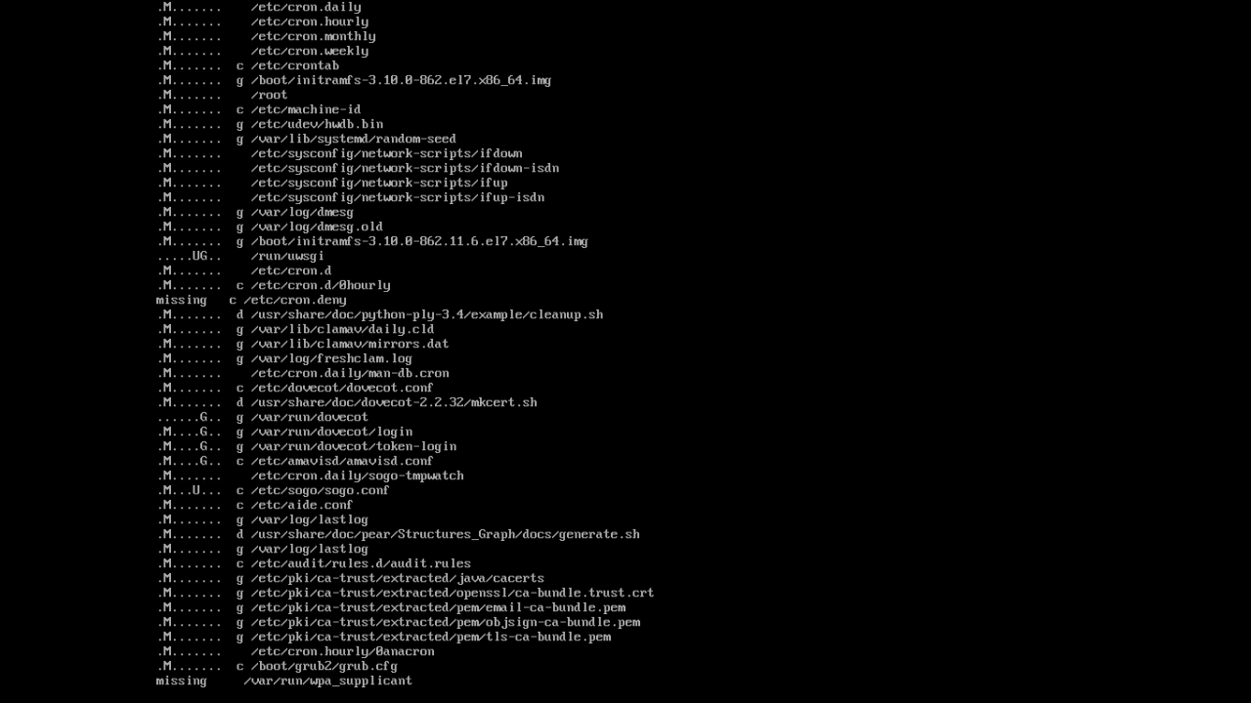

Politicas implementadas:

Crear politica de AIDE y logwatch

Crear politicas de banners

Crear politica de rotación de logs

Proceso de actualización:

bash /root/f2.sh

#yum check-update --security

#yum update –security

bash /root/firewall.sh

Comandos utiles:

fdisk -l
df –local -P
ip a

